MORNING WORSHIP SERVICE
Jan 7, 2018

Opening “We Have Come into His House” 361

Opening Prayer/Announcements

Worship Hymns “More About Jesus” 600
“We’ll Work Till Jesus Comes” 608
“Send the Light” 595
“Teach Me, O Lord, I Pray” 601

Offertory
Sr. Women’s Sunday School Class Topics

Jan 7th Achsah – Caleb’s daughter Joshua 15:13-19
Jan 14th Adah & Zillah – Lamech’s two wives Genesis 4:19-24
Jan 21st Ahinoam – The wife of Saul 1 Samuel 14:50
Jan 28th Bilhah & Zilpah – Two slaves Genesis 29-30; 35:22-25

Special Music

A Place for Everyone – See you there at 9:45
Sermon Bro. David Atwood
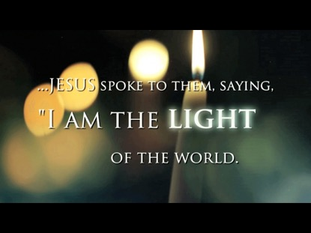
W

Invitation “Grace Greater than Our Sin” 329

Evening Service @ 6:00 pm

NURSERY – available for children age 0 to Kindergarten
Judy Broussard & Shirley Marecle

Hostesses/Hosts for Jan Ushers for Jan
Sheila Waggoner, Judy Broussard Tom Veilleux, Wesley McManus
Jane Tooley Wayne Marecle, David Condron

Immediate Need Prayer List
Prayer & Request Information

(Please complete name & address information on reverse side)

❑ I would like to speak with the Pastor.

❑ I would like more information on this church.

❑ I have Prayer Requests or Needs

Date:

Permission to Publicize:
Church Bulletin  Yes  No
Email Prayer Chain  Yes  No

Prayer Request:

Prayer For
Name
Address
Phone

Given By
Name
Address
Phone
Please Contact By

❑ Card  Phone  Visit

Comments

Please pray for continued progress for Scott Ruthven
Pray for Maxine Morris (Diann Stutes’ sister). She is undergoing cancer treatments.
K s b c

Keeping His Word through Sunday School, Bible Study and Church Attendance/Worship

Sunday School Bible Studies for Jan:

Jan 7th Jesus Provides Mark 6:34-44
Jan 14th Jesus Corrects Mark 7:5-15
Jan 21st I Am Wonderfully Made Psalm 139:1-6,13-18
Jan 28th I Am a Child of the King Galatians 4:1-7

